**Họ và tên: Phạm Quang Dinh**

**MSSV: 22520252**

**LAB5.1**

Ảnh kết quả

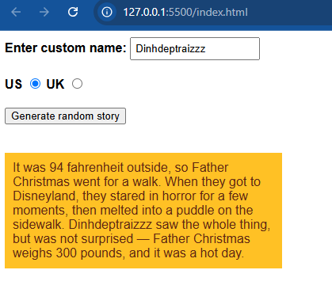

Ảnh Source code

**LAB5.2**

Ảnh kết quả

Ảnh Source:  
